1. WITHDRAW_MONEY Use Case Description (ATM System)

|  |  |
| --- | --- |
| User Action | System Response |
| * User types in PIN into main screen | * System checks validity of PIN and presents options to user on another screen (Checking_Account, Saving_Account) |
| * User selects Checking Account. | * System verifies the user account type and shows available options (Check Balance, Withdraw Money). |
| * User selects “Withdraw Money” | * System verifies if user is allowed to withdraw and shows input box to enter amount. |
| * User enter amount to withdraw and hit confirm. | * System checks available balance and if user is within day limit and if there’s enough cash in machine. If yes, updates the user balance and process the transaction. |

1. 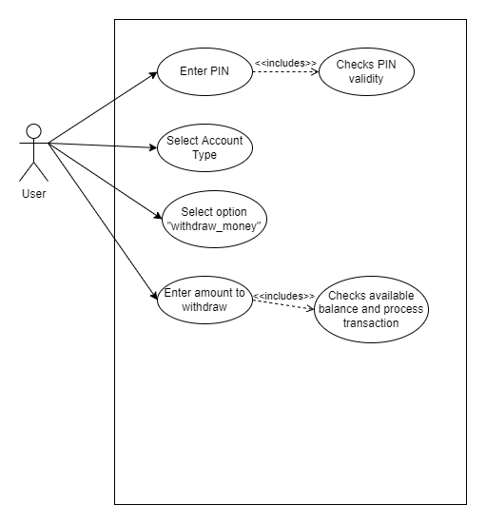 A Use Case Diagram for the ATM System
2. The Project Management Tracking System (class diagram)

|  |
| --- |
| **Release** |
| * releaseName: String * deliverDate: date * featureSets: List<Feature> |
|  |

|  |
| --- |
| **Manager** |
| * name: String * projects: List<Project> |
|  |

|  |
| --- |
| **Project** |
| * projectName: String * status: String * releases: List<Release> |
|  |

|  |
| --- |
| **Feature** |
| * featureName: String |
|  |

|  |
| --- |
| **Developer** |
| * id: long * estimatedTime: String * feature: Feature |
|  |

1. Properties Management System (class diagram)

|  |
| --- |
| **Landlord** |
| * name: String * properties: List<Property> |
|  |

|  |
| --- |
| **<<Interface>>**  **Property** |
| * address: Address * rent: Rent |
|  |

|  |
| --- |
| **Trailer** |
| * trailerParkName |
|  |

|  |
| --- |
| **Condominium** |
| * floors: int |
|  |

|  |
| --- |
| **Address** |
| * city: String |
|  |

|  |
| --- |
| **House** |
| * lotSize: int |
|  |

|  |
| --- |
| **Rent** |
| * rentValue: double |
|  |